Infinitive Phrase

✅ Definition:
# Source: AI Source: Provided by: [Data Path: Persons Table -> ID Column: 1, Name_En Column: Motasem Essam] -> From: [Chatgpt (GPT-4-turbo)] on [7/28/2025]
An infinitive phrase is a group of words that begins with an infinitive (the base form of a verb preceded by "to") and includes modifiers, objects, or complements.
It functions as a noun, adjective, or adverb in a sentence.

🧩 Structure of an Infinitive Phrase:
# Source: AI Source: Provided by: [Data Path: Persons Table -> ID Column: 1, Name_En Column: Motasem Essam] -> From: [Chatgpt (GPT-4-turbo)] on [7/28/2025]
to + base verb + (modifiers, objects, complements)
🔹 to eat dinner quickly
🔹 to win the game with effort
🔹 to understand the lesson fully

✏️ Examples of Infinitive Phrases:
# Source: AI Source: Provided by: [Data Path: Persons Table -> ID Column: 1, Name_En Column: Motasem Essam] -> From: [Chatgpt (GPT-4-turbo)] on [7/28/2025]
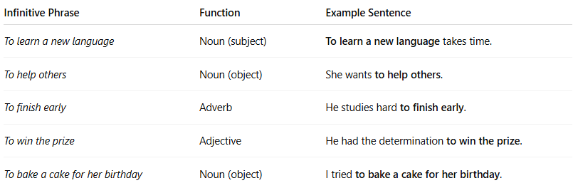
Infinitive Phrase | Function | Example Sentence
To learn a new language | Noun (subject) | To learn a new language takes time.
To help others | Noun (object) | She wants to help others.
To finish early | Adverb | He studies hard to finish early.
To win the prize | Adjective | He had the determination to win the prize.
To bake a cake for her birthday | Noun (object) | I tried to bake a cake for her birthday.

🎯 Functions of Infinitive Phrases:
# Source: AI Source: Provided by: [Data Path: Persons Table -> ID Column: 1, Name_En Column: Motasem Essam] -> From: [Chatgpt (GPT-4-turbo)] on [7/28/2025]
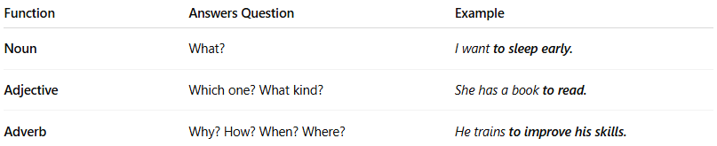
Function | Answers Question | Example
Noun | What? | I want to sleep early.
Adjective | Which one? What kind? | She has a book to read.
Adverb | Why? How? When? Where? | He trains to improve his skills.

🧠 Infinitive vs. Prepositional Phrase:
# Source: AI Source: Provided by: [Data Path: Persons Table -> ID Column: 1, Name_En Column: Motasem Essam] -> From: [Chatgpt (GPT-4-turbo)] on [7/28/2025]
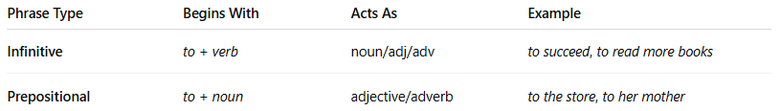

Phrase Type | Begins With | Acts As | Example
Infinitive | to + verb | noun/adj/adv | to succeed, to read more books
Prepositional | to + noun | adjective/adverb | to the store, to her mother
🔹 He went to the doctor. → Prepositional phrase
🔹 He wants to become a doctor. → Infinitive phrase

⚠️ Split Infinitives (Optional Note):
# Source: AI Source: Provided by: [Data Path: Persons Table -> ID Column: 1, Name_En Column: Motasem Essam] -> From: [Chatgpt (GPT-4-turbo)] on [7/28/2025]
A split infinitive places a word (usually an adverb) between to and the verb.
✅ to boldly go where no one has gone before
🔁 (Traditional rule: avoid splitting — to go boldly)
Modern usage often accepts split infinitives for clarity or emphasis.

🧠 Summary Table:
# Source: AI Source: Provided by: [Data Path: Persons Table -> ID Column: 1, Name_En Column: Motasem Essam] -> From: [Chatgpt (GPT-4-turbo)] on [7/28/2025]
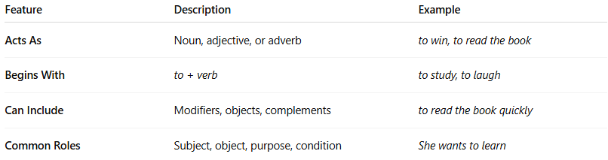
Feature | Description | Example
Acts As | Noun, adjective, or adverb | to win, to read the book
Begins With | to + verb | to study, to laugh
Can Include | Modifiers, objects, complements | to read the book quickly
Common Roles | Subject, object, purpose, condition | She wants to learn

